**EATON CORPORATION**

**POWER ADVANTAGE PARTNER PROGRAM**

**TERMS AND CONDITIONS**

**The Eaton Corporation (“EATON”) reseller partner participating in this PowerAdvantage Partner Program (“PARTICIPANT”) hereby agrees to the following (“AGREEMENT”):**

**1. Power Advantage Partner Program (“PROGRAM”) Eligibility:**

**To be eligible for this Program:**

* 1. PARTICIPANT must be a reseller of information technology products and/or services (servers, storage, workstations, networking gear, notebook computers, computer peripherals, etc.) to end users
  2. PARTICIPANT must have a valid tax ID
  3. PARTICIPANT shall demonstrate commitment and dedication to the development of incremental business in Eaton products as well as to increasing awareness of the Eaton brand name
  4. PARTICIPANT agrees to be bound by the terms and conditions of this Agreement and any modifications to the terms of this Agreement in order to be eligible for the PROGRAM

**2. Obligations of EATON**

* 1. EATON shall designate PARTICIPANT as a REGISTERED PARTNER in the PROGRAM should PARTICIPANT comply with the defined requirements (as defined in the Appendix) and shall provide PARTICIPANT with all the benefits afforded to an REGISTERED PARTNER
  2. EATON shall designate PARTICIPANT as an AUTHORIZED PARTNER in the PROGRAM should PARTICIPANT comply with the defined requirements (as defined in the Appendix) and shall provide PARTICIPANT with all the benefits afforded to an AUTHORIZED PARTNER
  3. EATON shall designate PARTICIPANT as a PREMIUM PARTNER in the PROGRAM should PARTICIPANT comply with the defined requirements (as defined in the Appendix) and shall provide PARTICIPANT with all the benefits afforded to a PREMIUM PARTNER

**3. Obligations of PARTICIPANT**

* 1. PARTICIPANT agrees to receive communications from time to time from Eaton on products and promotions directly relevant to the PARTICIPANT’S line of business
  2. PARTICIPANT agrees to allow Eaton to use PARTICIPANT’S name in promotional materials, including press releases, presentations, customer references and reseller lists regarding the sale of Eaton products. Eaton will obtain PARTICIPANTS prior written approval for publicity documents that contains claims, quotes, endorsements or attributions by PARTICIPANT
  3. PARTICIPANT must provide Eaton their unique customer number from each of Eaton’s Authorized IT Distributor(s) (as defined in Schedule C) with which it does business. Orders associated with each of these customer numbers at Eaton’s Authorized IT Distributors will receive the defined benefits (as defined in schedule B)
  4. PARTICIPANT must comply with all federal, state and local laws and regulations governing the advertising, marketing and sale of Eaton Products
  5. PARTICIPANT may not represent Eaton products in a negative, misleading or deceptive manner
  6. PARTICIPANT shall comply with any logo or trademark usage guidelines issued by Eaton in connection with the PROGRAM

**4. Miscellaneous**

* 1. The term of this AGREEMENT shall commence upon the date Eaton provides written notice (includes email notice) to PARTICIPANT of its acceptance into the PROGRAM. Each party may terminate this AGREEMENT with or without cause at any time. Upon termination, PARTICIPANT will be removed from the PROGRAM and all future purchases/sales, from the date of termination, will not be eligible for any discounts allowed for in this Program
  2. Participant understands that the term of this AGREEMENT is one (1) year, which may be renewed by Eaton for additional terms at Eaton’s discretion
  3. The Program is valid only for purchases/sales in Europe, Middle East and Africa.
  4. EATON reserves the right to modify the terms of this Agreement or withdraw the Program at any time at its sole discretion

**5. Intellectual Property Rights**

* 1. Eaton shall remain the owner of its intellectual property and nothing contained in this undertaking shall imply any transfer of title of any intellectual property and all intellectual property rights existing before or generated after the signature date of this undertaking or generated under this undertaking shall have full title to such rights
  2. Eaton grants herewith a non-exclusive, royalty free right to the PARTICIPANT to use the trademarks listed in the above Recitals for the purpose and during the duration of this authorization
  3. The PARTICIPANT shall not do or authorize any third person to do any act which would or might damage or be inconsistent with the trademarks (which term for purposes of this authorization shall include but not be limited to trademarks, trade names, service marks, logo marks, trade dress other trade names, whether registered or unregistered) used by Eaton in relation to the Products or to the goodwill associated therewith and, in particular, will not do or authorize the alteration, obliteration, covering up or incorporation of other marks (in whole or in part) on to the Products
  4. Except as expressly authorized in terms of this authorization, the PARTICIPANT shall not use or authorize any third person to use the trademarks used by Eaton in relation to the Products on any stationery, advertising, promotion or selling material other than the Products or other such materials supplied by Eaton to the PARTICIPANT. All advertising, promotion and selling materials supplied by Eaton to the PARTICIPANT shall remain the property of Eaton and the PARTICIPANT shall not permit any other person to make use thereof
  5. The use in any form of the name "EATON" or Eaton's logo in the official name, company name, trading or business name, domain name or other similar name of the PARTICIPANT requires the prior written approval of Eaton
  6. The PARTICIPANT agrees to inform Eaton promptly about any infringement of any of Eaton’s trademarks or other intellectual property rights or of any act of unfair competition of which the PARTICIPANT has knowledge. Eaton and the PARTICIPANT shall then jointly decide on appropriate action. The PARTICIPANT agrees to assist in every way possible in legal actions taken by Eaton or its affiliates in this regard
  7. The PARTICIPANT shall keep confidential all data, information, specifications, documentation, and other material (tangible or intangible) which is disclosed by Eaton to The PARTICIPANT and designated by Eaton as confidential. The PARTICIPANT’s obligations and Eaton’s rights under this Section shall survive any expiration or termination of this letter for any reason whatsoever for a period of five (5) years thereafter

**6. Confidential Information**

* 1. Confidential Information shall mean information that either party marks or otherwise conspicuously identifies as confidential, or which the receiving party should reasonably understand to be confidential, including but not limited to: non-public information about Products and Services; business plans; market data; financial data; customer data; and sales information
  2. Each party shall:

6.2.1. use the same care and discretion to avoid disclosure, publication or dissemination of Confidential Information as it uses with its similar information that it keeps confidential, but in no case less than a reasonable standard of care

6.2.2 use Confidential Information solely for the purpose for which it was disclosed or otherwise for the benefit of the discloser

* 1. Either party may disclose Confidential Information to:

6.3.1 employees of entities within its Enterprise that have a need to know in order to accomplish the purposes of this AGREEMENT

6.3.2 any third party with the discloser’s prior written consent

6.4 Any disclosure of Confidential Information by a party to a third party shall be on terms no less restrictive than those in this Agreement

6.5 Confidential Information shall not include information that is: i) already in the possession of a party without obligation of confidentiality; ii) developed by a party independently of Confidential Information received from the other party; iii) obtained from a source other than the other party without obligation of confidentiality; iv publicly available when received or subsequently made publicly available through no fault of the recipient; or v) disclosed to a third party without obligation of confidentiality

6.6 Either party may use the ideas, concepts and know-how contained in the Confidential Information of the other which is retained in the unaided memories of recipient’s employees

6.7 CONFIDENTIAL INFORMATION OF EITHER PARTY IS PROVIDED “AS IS” AND WITHOUT WARRANTIES OF ANY KIND, WHETHER EXPRESS, STATUTORY OR IMPLIED

6.8 The receipt of Confidential Information by either party shall not preclude, or in any way limit, the recipient from: 1) providing to others products or services which may be competitive with products or services of the discloser; 2) providing products or services to others who compete with the discloser; or 3) assigning its employees in its sole discretion

6.9 Either party may disclose Confidential Information of the other to the extent required by law; however, the recipient shall promptly notify the discloser of any such requirement in order that the discloser may take action to prevent or limit such disclosure

**7. Status Change**

PARTICIPANT shall provide prompt written notice to EATON of any substantive change to the information provided in the Eaton PowerAdvantage Partner Program’s application. Upon notification of such change, or in the event of PARTICIPANT’s failure to provide notice of such change, EATON may, at its sole discretion, terminate this Agreement.

**8.** **Limitation of Liability**

To the maximum extent permitted by applicable law and regardless of whether any remedy set forth herein fails of its essential purpose, in no event will EATON or its resellers, suppliers or agents be liable to You or any person under this AGREEMENT or otherwise (i) for lost profits, loss of use, loss of or corruption of data, loss of good will, business interruption, loss of production, loss of revenues, loss of contracts, or loss of anticipated savings or wasted management and staff time.

**9. PROGRAM Changes**

EATON reserves the right to modify, or terminate, the PROGRAM, including any condition, requirement or benefit, in whole or in part. All such changes shall be effective upon notice to You or at such time that EATON may specify, provided that EATON will use commercially reasonable efforts to give You thirty (30) days-notice of any material change to the PROGRAM. Should You disagree with any change or modification, You may terminate this AGREEMENT (and Your participation to the PROGRAM) in accordance with applicable Agreement terms.

**Schedule A - PROGRAM Requirements**

* Agree to T&C’s set forth in this document
* Comply with the PROGRAM Requirement list based on the PARTICIPANT program tier level

**Schedule B – PROGRAM Benefits**

* PARTICIPANT is eligible to the attached PROGRAM benefits list based on the PARTICIPANT program tier level
* PROGRAM logo usage.

In compliance with EATON’s logo guidelines as dictated by the terms of use, PARTICIPANT is eligible to use either the Eaton Authorized or Premium Reseller logo based on the PARTICIPANT’s tier level

**Schedule C - Eaton Authorized IT Distributors Benelux 2018**

* ALSO
* COPACO
* INGRAM MICRO
* TECH DATA

**APPENDIX**

1. **Eaton Power Advantage Partner Program Requirements Grid**



|  |  |
| --- | --- |
| **Market TIER** | **COUNTRY** |
| **T1** | Belgium, France, Germany, Netherlands, Sweden, UK |
| **T2** | Austria, Italy, Middle East, Russia, Spain |
| **T3** | Africa, CEE, Denmark, Finland, Luxemburg, Norway, Portugal, South Africa, Switzerland |



1. **Eaton PowerAdvantage Partner Program Benefits Grid**

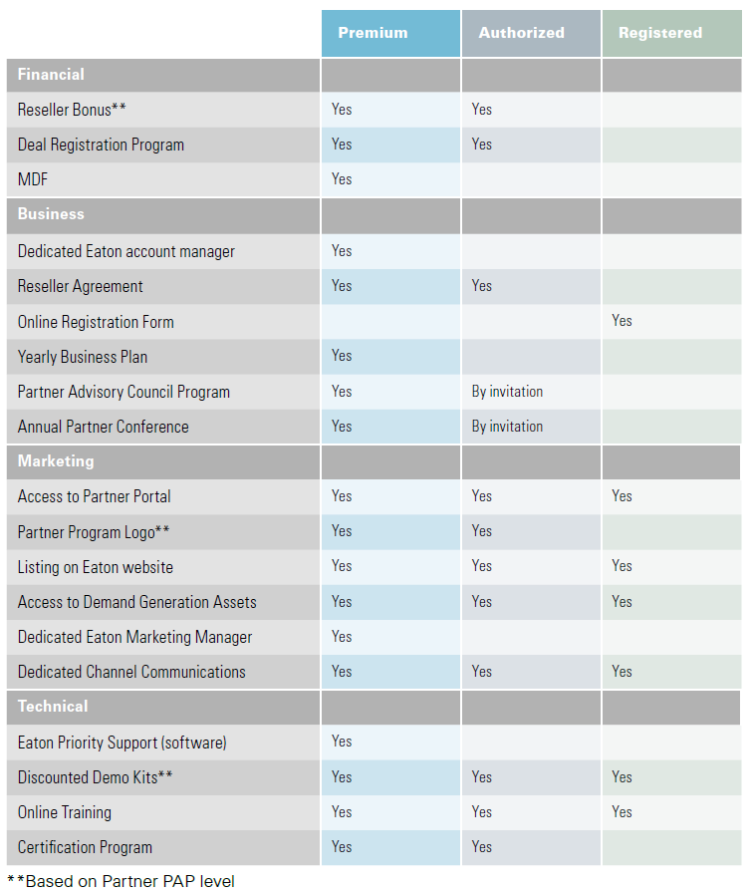

Copyright ©2018 Eaton Corporation. All rights reserved. By signing these terms and conditions, you agree to abide by the Eaton Power Advantage Partner Program